Network Programmability and Automation



Huawei Technologies Co., Ltd.

|  |
| --- |
| **Copyright © Huawei Technologies Co., Ltd. 2020. All rights reserved.**  No part of this document may be reproduced or transmitted in any form or by any means without prior written consent of Huawei Technologies Co., Ltd.  **Trademarks and Permissions**  HW_POS_RBG_Vertical-150ppi.png and other Huawei trademarks are trademarks of Huawei Technologies Co., Ltd.  All other trademarks and trade names mentioned in this document are the property of their respective holders.  **Notice**  The purchased products, services and features are stipulated by the contract made between Huawei and the customer. All or part of the products, services and features described in this document may not be within the purchase scope or the usage scope. Unless otherwise specified in the contract, all statements, information, and recommendations in this document are provided "AS IS" without warranties, guarantees or representations of any kind, either express or implied.  The information in this document is subject to change without notice. Every effort has been made in the preparation of this document to ensure accuracy of the contents, but all statements, information, and recommendations in this document do not constitute a warranty of any kind, express or implied. |

|  |  |
| --- | --- |
| Huawei Technologies Co., Ltd. | |
| Address: | Huawei Industrial Base  Bantian, Longgang  Shenzhen 518129  People's Republic of China |
| Website: | <https://e.huawei.com/> |

**Huawei Certification System**

Huawei Certification follows the "platform + ecosystem" development strategy, which is a new collaborative architecture of ICT infrastructure based on "Cloud-Pipe-Terminal". Huawei has set up a complete certification system consisting of three categories: ICT infrastructure certification, platform and service certification, and ICT vertical certification. It is the only certification system that covers all ICT technical fields in the industry. Huawei offers three levels of certification: Huawei Certified ICT Associate (HCIA), Huawei Certified ICT Professional (HCIP), and Huawei Certified ICT Expert (HCIE). Huawei Certification covers all ICT fields and adapts to the industry trend of ICT convergence. With its leading talent development system and certification standards, it is committed to fostering new ICT talent in the digital era, and building a sound ICT talent ecosystem.

Huawei Certified ICT Associate-Datacom (HCIA-Datacom) is designed for Huawei's frontline engineers and anyone who want to understand Huawei's datacom products and technologies. The HCIA-Datacom certification covers routing and switching principles, basic WLAN principles, network security basics, network management and O&M basics, SDN and programmability and automation basics.

The Huawei certification system introduces the industry, fosters innovation, and imparts cutting-edge datacom knowledge.

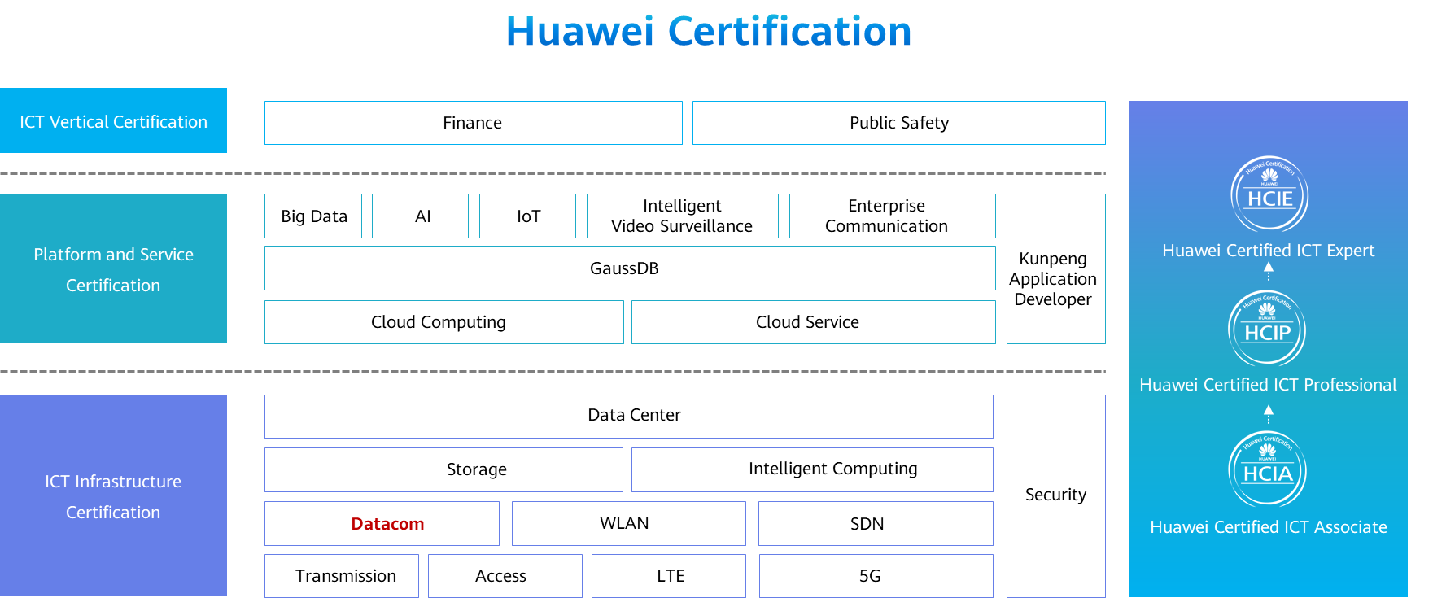

Contents

[1 Network Programmability and Automation 1](#_Toc59717254)

[1.1 Foreword 1](#_Toc59717255)

[1.2 Objectives 1](#_Toc59717256)

[1.3 Introduction to Network Programmability and Automation 1](#_Toc59717257)

[1.3.1 Background: Difficulties in Conventional Network O&M 1](#_Toc59717258)

[1.3.2 Network Automation 2](#_Toc59717259)

[1.3.3 Programming-based Network Automation 3](#_Toc59717260)

[1.4 Overview of Programming Language and Python 3](#_Toc59717261)

[1.4.1 Programming Languages 3](#_Toc59717262)

[1.4.2 Computing Technology Stack and Program Execution Process 4](#_Toc59717263)

[1.4.3 High-level Programming Language 5](#_Toc59717264)

[1.4.4 What Is Python? 6](#_Toc59717265)

[1.4.5 Python Code Execution Process 7](#_Toc59717266)

[1.4.6 Getting Started with Python Code 7](#_Toc59717267)

[1.4.7 Code Style Guide for Python 8](#_Toc59717268)

[1.4.8 Code Style Guide for Python - Identifier Naming 9](#_Toc59717269)

[1.4.9 Code Style Guide for Python - Code Indentation 9](#_Toc59717270)

[1.4.10 Code Style Guide for Python - Using Comments 10](#_Toc59717271)

[1.4.11 Code Style Guide for Python - Source Code File Structure 10](#_Toc59717272)

[1.4.12 Python Functions and Modules 11](#_Toc59717273)

[1.4.13 Python Classes and Methods 11](#_Toc59717274)

[1.4.14 Introduction to telnetlib 12](#_Toc59717275)

[1.5 Cases 13](#_Toc59717276)

[1.5.1 Case: Logging In to a Device Using telnetlib 13](#_Toc59717277)

[1.5.2 Case: Running Result Comparison 15](#_Toc59717278)

[1.6 Quiz 15](#_Toc59717279)

[1.7 Summary 15](#_Toc59717280)

# Network Programmability and Automation

## Foreword

New protocols, technologies, and delivery and O&M modes are emerging in the network engineering field. Conventional networks face challenges from new connection requirements, such as requirements for cloud computing and artificial intelligence (AI). Enterprises are also pursuing service agility, flexibility, and elasticity. Against this backdrop, network automation becomes increasingly important.

Network programmability and automation is to simplify network configuration, management, monitoring, and operations for engineers and improve deployment and O&M efficiency. This course is to help network engineers understand Python programming and implement network automation.

## Objectives

On completion of this course, you will be able to:

* Describe the difficulties of conventional network O&M.
* Understand the implementation of network automation.
* Understand the classification of programming languages.
* Describe the Python code style.
* Describe the basic usage of Python telnetlib.

## Introduction to Network Programmability and Automation

### Background: Difficulties in Conventional Network O&M

Conventional network O&M requires network engineers to manually log in to network devices, query and execute configuration commands, and filter command output. This highly human-dependent working mode is time-consuming, inefficient, and difficult to audit.

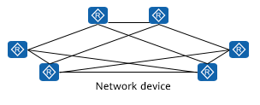

Conventional Network O&M

Typical O&M Scenarios

Are the following working scenes familiar to you?

* Device upgrade: Thousands of network devices reside on a live network. You have to periodically upgrade the devices in batches.
* Configuration audit: An enterprise needs to audit the configuration of devices every year. For example, the enterprise requires that STelnet be enabled on all devices and spanning tree security be configured on Ethernet switches. In this case, you have to quickly find out the devices that do not meet the requirements.
* Configuration change: Due to network security requirements, device accounts and passwords need to be changed every three months. You have to delete the original account and create an account on thousands of network devices.

### Network Automation

Network automation: Tools are used to implement automated network deployment, operations, and O&M, gradually reducing dependency on human. This solves the conventional network O&M problems.

Many open-source tools, such as Ansible, SaltStack, Puppet, and Chef, are available for network automation in the industry. From the perspective of network engineering capability construction, it is recommended that engineers acquire the code programming capability.

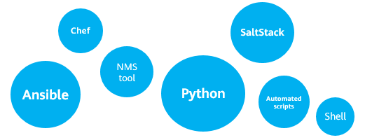

Keywords of network automation

Many network automation tools in the industry, such as Ansible, SaltStack, Puppet, and Chef, are derived from open-source tools. It is recommended that network engineers acquire the code programming capability.

### Programming-based Network Automation

In recent years, with the emergence of network automation technologies, Python-based programming capabilities have become a new skill requirement for network engineers.

Automation script written in Python can execute repeated, time-consuming, and rule-based operations.

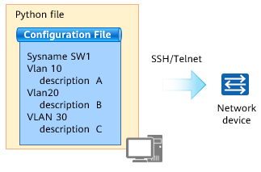

Implementing automated device configuration using Python

What can network automation do? The most intuitive example of network automation is automated device configuration. This process can be divided into two steps: writing a configuration file, and writing Python code to push the configuration file to a device.

Write the configuration script in command line interface (CLI) mode, and then upload the script to the device using Telnet/SSH. This method is easy to understand for network engineers who are beginning to learn network programmability and automation. This presentation describes how to implement network automation.

## Overview of Programming Language and Python

### Programming Languages

A programming language is used to write a computer program and control behavior of a computer.

According to whether compilation is required before execution of a language, the programming language may be classified into the compiled language, and interpreted language that does not need to be compiled.

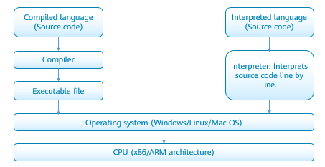

Programming Languages

Based on language levels, computer languages can also be classified into machine language, assembly language, and high-level language. The machine language consists of 0 and 1 instructions that can be directly identified by a machine. Because machine languages are obscure, hardware instructions 0 and 1 are encapsulated to facilitate identification and memory (such as MOV and ADD), which is assembly language. The two languages are low-level languages, and other languages are high-level languages, such as C, C++, Java, Python, Pascal, Lisp, Prolog, FoxPro, and Fortran. Programs written in high-level languages cannot be directly identified by computers. The programs must be converted into machine languages before being executed.

### Computing Technology Stack and Program Execution Process

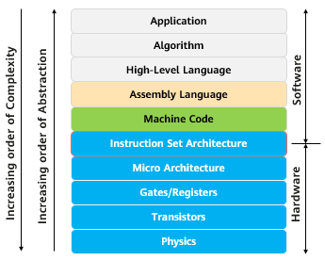

Computing Technology Stack

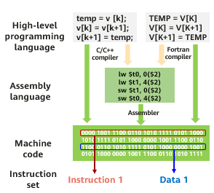

Program Execution Process

A process of executing a computer's technology stack and programs. On the left is the computing technology stack. From the bottom layer of the hardware, physical materials and transistors are used to implement gate circuits and registers, and then the micro architecture of the CPU is formed. The instruction set of the CPU is an interface between hardware and software. An application drives hardware to complete calculation using an instruction defined in the instruction set.

Applications use certain software algorithms to implement service functions. Programs are usually developed using high-level languages, such as C, C++, Java, Go, and Python. The high-level language needs to be compiled into an assembly language, and then the assembler converts the assembly language into binary machine code based on a CPU instruction set.

A program on disk is a binary machine code consisting of a pile of instructions and data, that is, a binary file.

### High-level Programming Language

Compiled Language

* Compiled language: Before a program in a compiled language is executed, a compilation process is performed to compile the program into a machine language file. The compilation result can be directly used without re-translation during running. Typical compiled languages include C/C++ and Go.
* From source code to program: The source code needs to be translated into machine instructions by the compiler and assembler, and then the linker uses the link library function to generate the machine language program. The machine language must match the instruction set of the CPU, which is loaded to the memory by the loader during running and executed by the CPU.

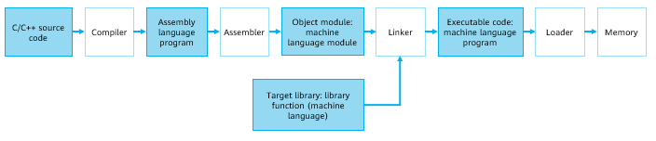

Compiled Language

* Compiled languages are compiled into formats, such as .exe, .dll, and .ocx, that can be executed by machines. Compilation and execution are separated and cannot be performed across platforms. For example, x86 programs cannot run on ARM servers.

Interpreted Language

* Interpreted language: Interpreted language programs do not need to be compiled before running. They are translated line by line when running. Typically, Java and Python are interpreted languages.
* Process from source code to programs: Source code of an interpreted language is generated by the compiler and then interpreted and executed by a virtual machine (VM) (for example, JVM/PVM). The VM shields the differences between CPU instruction sets. Therefore, portability of the interpreted language is relatively good.

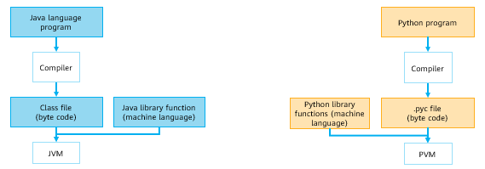

Interpreted Language

* JVM: Java virtual machine
* PVM: Python VM

### What Is Python?

Python is a fully-open-source high-level programming language. Its author is Guido Van Rossum.

Advantages of Python:

* Is a dynamically typed interpreted language with elegant syntax. It allows learners to focus on program logic rather than syntax detail learning.
* Supports both process- and object-oriented programming.
* Provides abundant third-party libraries.
* Is nicknamed the glue language because it can call code written in other languages.

Disadvantages of Python:

* Runs slow. Is an interpreted language that runs without being compiled. Code is translated line by line at run time into machine code that the CPU can understand, which is time-consuming.

With support for abundant third-party libraries and advantages of the Python language, Python can be used in many fields, such as AI, data science, apps, and scripts for automated O&M.

Python is also a dynamically typed language. The dynamically typed language automatically determines the type of variable during program running. The type of a variable does not need to be declared.

### Python Code Execution Process

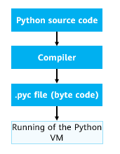

Process of compiling and running a Python program

Operation

1. Install Python and the running environment in an operating system.
2. Compile Python source code.
3. The compiler runs the Python source code and generates a .pyc file (byte code).
4. A Python VM converts the byte code into the machine language.
5. Hardware executes the machine language.

Python source code does not need to be compiled into binary code. Python can run programs directly from the source code. When Python code is run, the Python interpreter first converts the source code into byte code, and then the Python VM executes the byte code.

The Python VM is not an independent program and does not need to be installed independently.

### Getting Started with Python Code

Python runs in either interactive or script mode.

1、Interactive Running

Interactive programming does not require script files to be created, and code is written in the interactive mode of the Python interpreter.

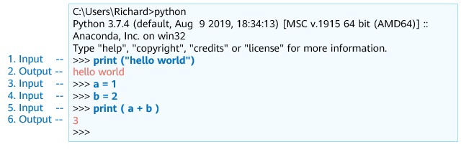

Interactive Running

2、Script-based Running

Code in script mode can run on various Python compilers or in integrated development environments. For example, IDLE, Atom, Visual Studio, Pycharm, and Anaconda provided by Python can be used.

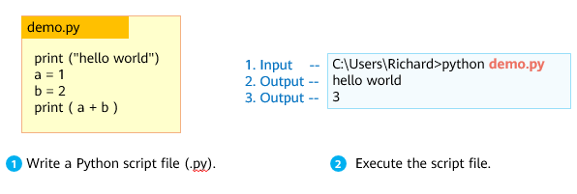

Script-based Running

### Code Style Guide for Python

Code style rules refer to naming rules, code indentation, and code and statement segmentation modes that must be complied with when Python is used to write code. Good style rules help improve code readability and facilitate code maintenance and modification.

For example, the following rules for using semicolons, parentheses, blank lines, and spaces are recommended:

Semicolon

* A semicolon can be added at the end of a line in Python, but is not recommended to separate statements.
* It is recommended that each sentence be in a separate line.

Parentheses

* Parentheses can be used for the continuation of long statements. Avoid unnecessary parentheses.

Blank line

* Different functions or statement blocks can be separated by spaces. A blank line helps differentiate two segments of code, improving code readability.

Space

* Spaces are not recommended in parentheses.
* You can determine whether to add spaces on both ends of an operator.

### Code Style Guide for Python - Identifier Naming

A Python identifier represents the name of a constant, variable, function, or another object.

An identifier is usually composed of letters, digits, and underscores, but cannot start with a digit. Identifiers are case sensitive and must be unique. If an identifier does not comply with the rules, the compiler will output a SyntaxError message when running the code.

Basic data types of Python are Boolean (True/False), integer, floating point, and string. All data (Boolean values, integers, floating points, strings, and even large data structures, functions, and programs) in Python exists in the form of objects. This makes the Python language highly unified.

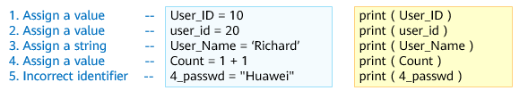

Identifier Naming

print() is a built-in function of Python and is used to output content in parentheses.

Question: What is the output of the print command on the right?

* The execution results are 10, 20, Richard, 2, and SyntaxError, respectively.

This presentation does not describe Python syntax. For Python syntax details, see the HCIP course.

### Code Style Guide for Python - Code Indentation

In Python programs, code indentation represents the scope of a code block. If a code block contains two or more statements, the statements must have the same indentation. For Python, code indentation is a syntax rule that uses code indentation and colons to distinguish between layers of code.

When writing code, you are advised to use four spaces for indentation. If incorrect indentation is used in the program code, an IndentationError error message is displayed during code running.

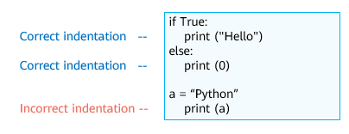

Code Indentation

if...else... is a complete block of code with the same indentation.

print(a) calls parameter a, and it is in the same code block with if...else...clause.

### Code Style Guide for Python - Using Comments

Comments are explanations added to programs to improve program readability. In the Python program, comments are classified into single-line comments and multi-line comments.

A single-line comment starts with a pound sign (#).

A multi-line comment can contain multiple lines, which are enclosed in a pair of three quotation marks ('''...''' or '''''' ...'''''').

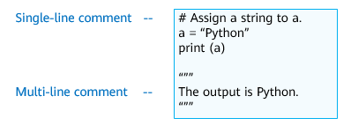

Using Comments

### Code Style Guide for Python - Source Code File Structure

A complete Python source code file generally consists of interpreter and encoding format declaration, document string, module import, and running code.

If you need to call a class of a standard library or a third-party library in a program, use "import" or "from... import" statement to import related modules. The import statement is always after the module comment or document string (docstring) at the top of the file.

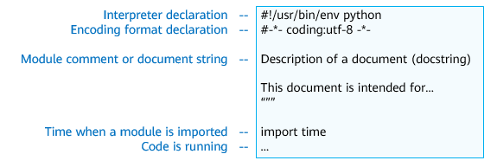

Source Code File Structure

The interpreter declaration is used to specify the path of the compiler that runs this file (the compiler is installed in a non-default path or there are multiple Python compilers). In the Windows , you can omit the first line of the interpreter declaration in the preceding example.

The encoding format declaration is used to specify the encoding type used by the program to read the source code. By default, Python 2 uses ASCII code (Chinese is not supported), and Python 3 supports UTF-8 code (Chinese is supported).

docstring is used to describe the functions of the program.

time is a built-in module of Python and provides functions related to processing time.

### Python Functions and Modules

A function is a block of organized, reusable code that is used to perform a single, related action. It can improve the modularity of the program and code utilization. The function is defined using the def keyword.

A module is a saved Python file. Modules can contain definitions of functions, classes, and variables that can then be utilized in other Python programs. The only difference between a module and a regular Python program is that the module is used for importing by other programs. Therefore, a module usually does not have a main function.

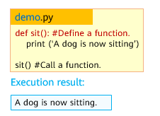

Write a Python file (.py).

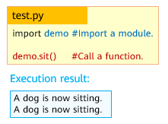

Import a module.

### Python Classes and Methods

A class is a collection of properties and methods that are the same. The class keyword is used to define a class.

The function of an instantiated class is called a method. When you define a method, a class must carry the **self** keyword, which indicates the instance of the class.

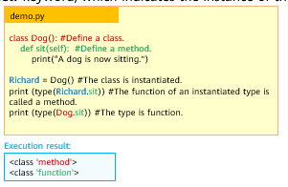

Write a Python file (.py).

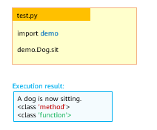

Import a module.

Official definitions of functions and methods:

* A series of statements which returns some value to a caller. It can also be passed zero or more arguments which may be used in the execution of the body.
* A function which is defined inside a class body. If called as an attribute of an instance of that class, the method will get the instance object as its first argument (which is usually called self).

For more information about classes, see https://docs.python.org/3/tutorial/classes.html.

### Introduction to telnetlib

telnetlib is a module in the standard Python library. It provides the telnetlib.Telnet class for implementing the Telnet function.

Different methods in the telnetlib.Telnet class are called to implement different functions.

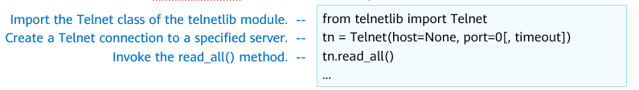

Introduction to telnetlib

Introduction to telnetlib

|  |  |
| --- | --- |
| Method | Function |
| Telnet.read\_until (expected, timeout=None) | Read data until a given byte string, expected, is encountered or until timeout seconds have passed. |
| Telnet.read\_all () | Read all data until EOF as bytes; block until connection closed. |
| Telnet.read\_very\_eager() | Read everything that can be without blocking in I/O (eager). Raise EOFError if connection closed and no cooked data available. Return b'' if no cooked data available otherwise. Do not block unless in the midst of an IAC sequence. |
| Telnet.write(buffer) | Write a byte string to the socket, doubling any IAC characters. |
| Telnet.close() | Close the connection. |

Telnet defines the network virtual terminal (NVT). It describes the standard representation of data and sequences of commands transmitted over the Internet to shield the differences between platforms and operating systems. For example, different platforms have different line feed commands.

Telnet communication adopts the inband signaling mode. That is, Telnet commands are transmitted in data streams. To distinguish Telnet commands from common data, Telnet uses escape sequences. Each escape sequence consists of 2 bytes. The first byte (0xFF) is called Interpret As Command (IAC), which indicates that the second byte is a command. EOF is also a Telnet command. Its decimal code is 236.

A socket is an abstraction layer. Applications usually send requests or respond to network requests through sockets.

For more information, see https://docs.python.org/3/library/telnetlib.html.

## Cases

### Case: Logging In to a Device Using telnetlib

Case description :

* A network device functions as a Telnet server, and the Python telnetlib needs to be used as a Telnet client to log in to the device.

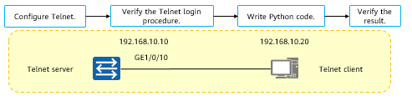

Logging In to a Device Using telnetlib (1)

The implementation process is as follows :

1. Configure the Telnet service.
2. Manually verify and view the Telnet login procedure as a reference for code implementation.
3. Compile and run Python code.
4. Verify the result.

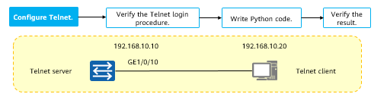

Logging In to a Device Using telnetlib (2)

Configure the IP address of interface on the device：

[Huawei] interface GE 1/0/0

[Huawei -GE1/0/0] ip add 192.168.10.10 24

[Huawei -GE1/0/0] quit

Configure the Telnet service：

[Huawei] user-interface vty 0 4

[Huawei-ui-vty0-4] authentication-mode password

[Huawei-ui-vty0-4] set authentication password simple Huawei@123

[Huawei-ui-vty0-4] protocol inbound telnet

[Huawei-ui-vty0-4] user privilege level 15

[Huawei-ui-vty0-4] quit

[Huawei] telnet server enable

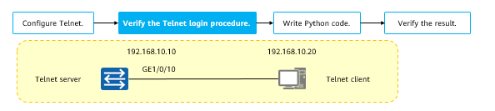

Logging In to a Device Using telnetlib (3)

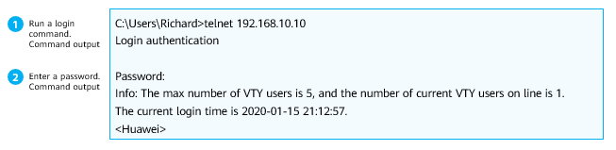

Telnet login:

* In this case, the Windows operating system is used as an example. Run the telnet 192.168.10.10 command. In the preceding step, a Telnet login password is set. Therefore, the command output is
* Password:
  + Enter the password Huawei@123 for authentication. The login is successful.

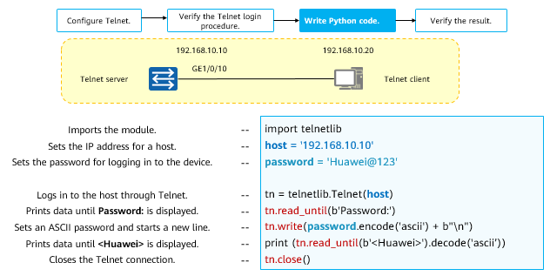

Logging In to a Device Using telnetlib (4)

In Python, the encode() and decode() functions are used to encode and decode strings in a specified format, respectively. In this example, password.encode('ascii') is to convert the string Huawei@123 into the ASCII format. The encoding format complies with the official requirements of the telnetlib module.

Add a string b, b'str', indicating that the string is a bytes object. In this example, b'Password:' indicates that the string Password:' is converted into a string of the bytes type. The encoding format complies with the official requirements of the telnetlib module.

For more information about Python objects, see https://docs.python.org/3/reference/datamodel.html#objects-values-and-types.

### Case: Running Result Comparison

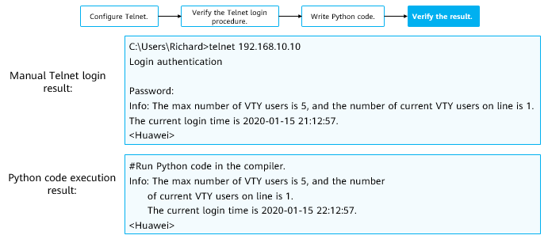

Running Result Comparison

## Quiz

1. (Single) Which of the following statements about OpenFlow is incorrect? ( )
2. OpenFlow is a protocol used to configure network switches. The process is similar to the application programming interface (API).
3. OpenFlow is an open source protocol.
4. OpenFlow switches forward packets based on flow tables.
5. OpenFlow is implemented through XML.
6. (Multiple) OpenFlow matches and processes network packets based on user-defined or preset rules. Which of the following are the components of an OpenFlow rule? ( )
7. Match Fields
8. Priority
9. Processing instructions
10. Statistics (such as Counters)
11. (Multiple) Which of the following statements about the key features of Network Functions Virtualization (NFV) is false? ( )
12. Centralized control and global efficiency optimization
13. Open interfaces and accelerate service rollout
14. Cloud-based upper-layer services and standard underlying hardware
15. Hierarchical operation, accelerating service rollout and innovation
16. (Multiple) In the SDN network architecture, which of the following belong to the application layer? ( )
17. Openstack
18. Third-party app platform
19. Server
20. Switch
21. (True or false) Huawei SDN network architecture supports various southbound and northbound interfaces, including OpenFlow, OVSDB, NETCONF, PCEP, RESTful, SNMP, BGP, JsonRPC, and RESTCONF. ( )
22. True
23. False
24. (True or false) Python is a compiled language. ( )
25. True
26. False
27. How to create VLAN 10 using telnetlib?

## Summary

Network automation uses tools to implement automated network deployment, operation, and O&M, gradually reducing dependency on people. You can use a programming language or tool to implement the network automation.

Python is a fully-open-source high-level programming language that is simple syntax and is easy to learn. It has rich standard libraries and third-party libraries, which are applicable to the network engineering field.

The telnetlib module of Python provides the telnetlib.Telnet class for implementing the Telnet function. It helps you enter the network programmability and automation world!